Physical Science NCFE Guided Review/Questions Standard 1.1

Distance/Displacement/Speed/Velocity

Distance = Displacement =

Speed = Velocity =

Equation:

Acceleration

3 Ways to change it:
1.
2.
3.

Equation:

Momentum

Depends on: _________________ and __________________
Examples for change in momentum:
1.
2.
3.

Equation:

Showing Motion on a Graph
Label the following motion types on the graph: constant velocity/speed, object at rest, positive acceleration, change in direction
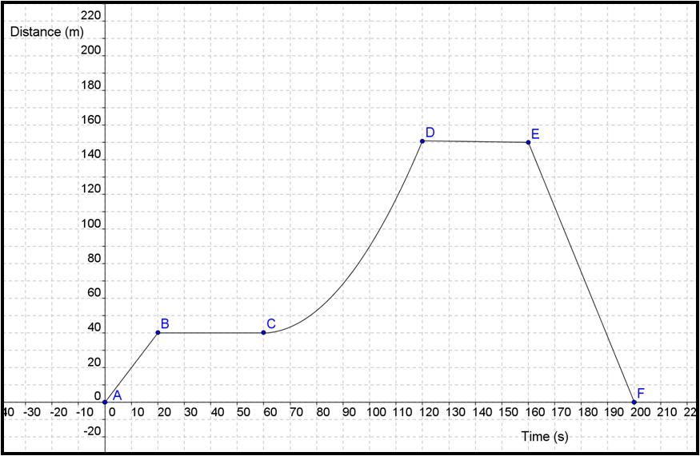

Solve/Interpret:
- What is the object’s average velocity at 130 seconds?

- What is the object’s acceleration between points C and D?

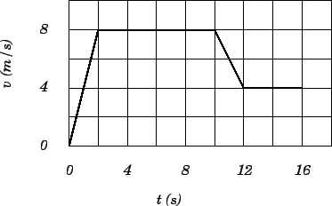

Label: positive acceleration, negative acceleration, constant velocity

