Physical Science NCFE Guided Review 3.1
(Energy, Work, Power, Simple Machines)

3.1.1 Explain thermal energy and its transfer.
Thermal Energy, Heat, Temperature
- Thermal Energy =
- Heat =
- Temperature =
- Phase Changes = during a phase change the _____________/_________ _________ increases or decreases, but the _____________ remains the same.
Conduction, Convection, Radiation
 | Definition | Example
Conduction
Convection
Radiation

3.1.2 Explain the law of conservation of energy in a mechanical system in terms of kinetic energy, potential energy and heat.
Kinetic Energy =
Potential Energy =
Heat Energy = type of energy that kinetic or potential is transformed into due to _________
Examples: Pendulum Roller Coaster

3.1.3 Explain work in terms of the relationship among the applied force to an object, the resulting displacement of the object, and the energy transferred to an object.
Conditions for Work
Work Happens When: Work Does Not Happen When:

Work Equation:

PSc.3.1.4 Explain the relationship among work, power and simple machines both qualitatively and quantitatively.
Power Equation:

Simple Machines
- Parts of complex machines
- Incline plane (wedge, screw), pulley, wheel/axle, lever

Ideal Mechanical Advantage Equation:

Actual Mechanical Advantage Equation:

Efficiency Equation:

Why is no machine 100% efficient?

Sample Questions

1. Which of the following occurs as a pot of soup on a hot burner begins to boil?
- Thermal energy is not transferred.
- Thermal energy is transferred from the burner to the air to the soup.
- Thermal energy is transferred from the burner to the pot to the soup.
- Thermal energy is transferred from the soup to the burner.

2. Why does a metal spoon feel colder to the touch than a wooden spoon at the same temperature?
- Metals have a lower boiling point than wood.
- Metals transfer more thermal energy.
- Wood is a better reflector of radiant energy.
- Wood has less mass than metal.

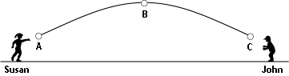

3. Which statement best describes the energy of the ball as it moves from position A to position B?
  - The total mechanical energy of the object increases.
  - The total energy of the object is constant neglecting air resistance.
  - The kinetic energy of the object is at a maximum at point B.
  - The potential energy of the object is constant.

4. What happens to the mechanical energy that the ball possesses after John catches the ball?
  - It remains mechanical energy but is transferred from the ball to John.
  - Kinetic energy of the ball is transformed into heat.
  - Potential energy of the ball is transformed into chemical energy.
  - The energy no longer exists.

5. A force of 50 newtons is applied to a rock for one hour. How much work is done on the rock if it does not move?
  - 3000 joules
  - 400 joules
  - 50 joules
  - 0 joules

6. How much work is done when 25 joules of energy is used to move a table 2.5 meters across a frictionless surface?
  - 0J
  - 20J
  - 25J
  - 30J

7. How much power is required to lift a 2.00-kg object 5.00 meters in 4.50 seconds?
  - 0.45 watts
  - 2.22 watts
  - 21.8 watts
  - 45.0 watts

8. A string is tied around a balance beam and hung so the balance beam is perfectly balanced. One cup is placed at the right end of the beam. Another cup is placed on the left side of the beam closer to the middle than the right cup. Two cubes are placed in the cup on the right.
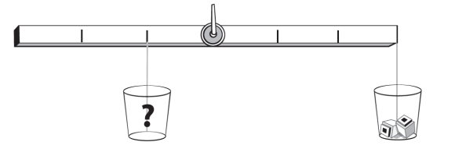

How many cubes should be placed in the left cup in order to balance the beam?
  - 2 cubes
  - 4 cubes
  - 6 cubes
  - 8 cubes

