True or False?
-Use the three rock charts to determine if each of the statements are true or false. -One a piece of paper, have student make two columns. Label one True and the other False.
-Cut out each statement and clue under the appropriate column. -On a separate piece of paper, rewrite all of the false statements and make them true.
Granite is a course grained sedimentary rock. Basalt has more than 50% dark materials. Andesite is calcium rich. Basalt has a glassy texture.
Peridotite has an ultramafic chemical composition. Granite is a light colored igneous rock. Breccia is a chemical sedimentary rock. Grain size 1⁄2 mm is classified as a medium texture. Fossilliferous limestone is made of shells.
The formula for rock salt is NaCl. Shale has the finest texture of sedimentary rocks.
Marble is a sedimentary rock. The parent rock for slate is limestone. Gneiss is foliated. Schist has undergone more metamorphism than slate. Anthracite is a non-foliated, fine textured, igneous rock. Gneiss has undergone more metamorphism than schist. Anthracite is a fine grained, non-foliated metamorphic rock. Granite has high silica content. Olivine is felsic, low iron and magnesium content.
*Here are some sample charts to use for the activity. Many more can be found on the internet ort in Earth Science textbooks.
http://depthome.brooklyn.cuny.edu/geology/core332/geofield.htm
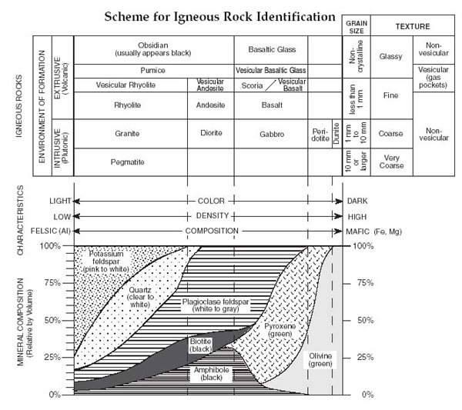
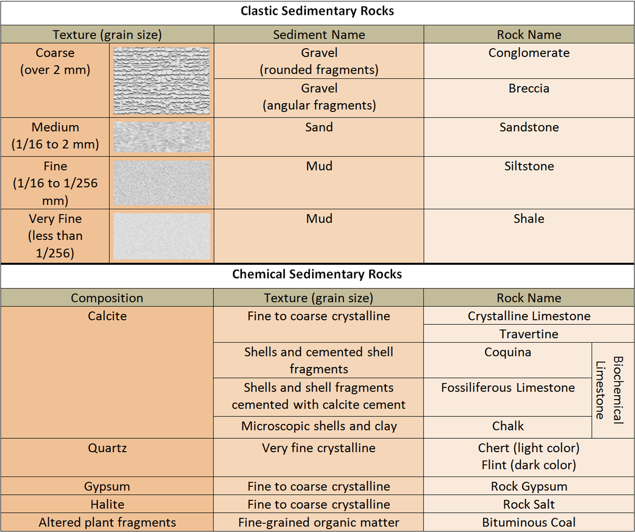
http://upload.wikimedia.org/wikipedia/commons/7/76/Sedimentary_Rock_Chart.png
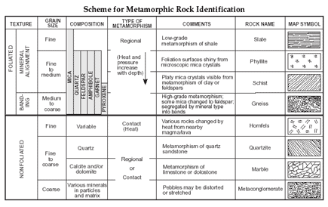
http://regentsprep.org/Regents/earthsci/units/rocks/metamorphicrockid.gif

